Will all GP practices in Somerset be extending their opening hours?
The introduction of this service means GP practices will be working together in local groups to extend the times when patients can attend a routine primary care appointment.

Patients can now attend additional routine appointments with a primary care clinician from 6.30pm to 8pm, Monday to Friday and some appointments over the weekend.

Not every GP practice will be offering appointments until 8pm, 7 days a week but patients will be able to access these appointments at a practice in their local area. Your practice will be working together with other local practices to extend the appointment times.

Groups of local practices have developed a rota to determine when each practice will be providing appointments until 8pm and at weekends. You can find out where the extended appointments are taking place on which day of the week by talking to your registered practice or ask the receptionist when booking an appointment.

There may be more than one practice providing appointments until 8pm depending on the size of the group.

A map showing the 10 provider groups can be found at the end of this document.

Will my own practice be extending its appointment times?
Your registered practice will be sharing the requirement to extend appointment times with a group of local practices.

This means that you and other patients registered with practices in this group will have access to appointments until 8pm. The location of the appointment will be within the local group of practices.

Will GP practices in my area take turns providing extended appointment times?
Yes, the ten groups of practices have locally developed a rota to determine when each practice will be providing appointments until 8pm and at weekends for the population in each group. There may be more than one practice providing appointments until 8pm depending on the size of the group.

You can get full details about which practice will be offering appointments until 8pm by speaking to a member of staff at your registered practice.

You can also ask a member of staff at your registered practice for the details of which other practices are members of the same provider group to get a better understanding of where an appointment may take place. You will also be able to find this information on practice websites.

If I go to an appointment at a practice where I am not registered, will they have access to my medical notes and will they know my medical background?
Yes, subject to consent from you to share your record. You will be asked to give consent at the time of booking and again before the consultation starts.

Patient safety is of utmost importance and at the time of booking an appointment with a different practice you will be asked if they are happy for your full notes to be shared.

If consent is given, the full primary care record will be accessible to the clinician holding the appointment. The record can only be accessed when you present for the appointment and give consent. The record will only be accessible to that clinician for 28 days after the appointment.

If you do not want to share your record outside of your GP practice, this will be recorded on the system and an alternative appointment at your registered practice will be offered.

Can I book an appointment outside the opening times of my practice?
You can book an appointment when your registered practice is open between 8am and 6.30pm every weekday. To find out more about how to book an appointment outside of your practice opening times e.g. at the weekend you can talk to your registered practice.

If someone becomes ill overnight or at the weekend and needs urgent medical advice outside of practice opening times, patients should continue to call NHS 111.

Can I book an appointment online?
Extended hours appointments will not be available to book online because the appointments will be offered by more than one practice. Your registered practice may decide to make a proportion of extended hour’s appointments available to book online if they are protected for their registered patients.

You can find out the full availability of extended hours appointments by speaking to a member of staff at your registered practice.

You can continue to book appointments online for appointments that will take place at your registered practice during core opening times (8pm - 6.30pm).

How far will I have to travel for an early morning / evening / weekend appointment?
This will depend on the location of the appointment being offered by your registered practice. You may also be offered a telephone consultation, removing the need to travel.

The ten groups of practices are based on geography. The map at the end of this document will help you to identify the location of your practice and the practices part of the same provider group.

The location of your appointment may only be different if the appointment offered is outside of your registered practice core opening times (8am – 6.30pm).

Extended appointments will take place at one of the practices in the same provider group as your registered practice. The location will be determined by the local rota developed by the group of practices. You will be made aware of the location of your appointment at the time of booking.
Will I be able to get an early morning or evening appointment?
It is a national requirement to ensure appointments are available until 8pm, Monday to Friday.

Early morning appointments are not a requirement but groups of practices may decide to have additional early morning appointments because they are of greater benefit for patients. You can ask your practice for details.

Will I be able to see my own GP outside of normal working hours?
You will be offered an appointment based on your needs and the availability of appointments.

You may be offered an appointment at a neighbouring practice and not with your regular GP. You do not have to accept this appointment and will be offered an alternative appointment, however this may result in a longer wait.

A booked appointment may not be with a GP but with a health care professional working within primary care. This could include a nurse practitioner, pharmacist, trained paramedic and health care assistants. You may also see a non-medical practitioner who can support patients with social challenges which can be linked to medical conditions.

Your booked appointment will be with a practitioner who will best meet your needs.

If I need an appointment outside normal working hours, can I choose to go to the one closest to my home / place of work / school or can I only go to the one in my primary care area?
Appointments will be offered based on your needs and the availability of appointments.

A practice can only book its registered patients into appointments at another practice that is part of the same provider group and only for appointments taking place between 6.30pm and 8pm and at weekends.

If you need an appointment during normal opening times you should continue to contact your registered practice in the normal way.

The registered practice can only book extended appointments with practices that are part of the same group for data protection and patient safety reasons.

Will people in full-time employment or school children be prioritised for appointments outside normal working hours?
Appointments will be offered by a practice based on the needs of a patient and the availability of appointments.

The service is expected to benefit those who do work full time or are unable to attend an appointment during opening hours (8am – 6.30pm).

If other practices in my area also extend their appointment times, won’t they prioritise their own registered patients over me?
No, practices within each group are allocated their fair share of extended appointments. This means appointments cannot be used up by one practice.

Will I be able to get an appointment at the weekend?
Yes, the groups of practices are required to offer weekend appointments based on the local needs of the population.

You should talk to your registered practice to obtain the details of how to book a weekend appointment.

Will any current services be reduced to cope with the additional demands of longer opening times?
You should continue to receive the same level of primary care service provision that is provided during normal opening times.

Is this different from the current GP Out Of Hours service?
Yes, this service extends the time when you can attend a routine primary care appointment.

The GP Out of Hours service is still available for patients with urgent, non-life threatening health related problems.

Patients should continue to use the Out of Hours service by calling 111 outside of practice opening times for urgent, non-life threatening health related problems.

Patients should call 999 for urgent, life threatening illnesses or injury.

Have patients or PPGs (patient participation groups) been involved in planning these changes?
Yes, practices should have engaged with both patients and Patient Participation Groups (PPGs) regarding the introduction of extended appointment availability and the locally developed service model.

Somerset Clinical Commissioning Group (CCG) also informed the PPG Chairs about the introduction of this service at its meeting in April 2017.

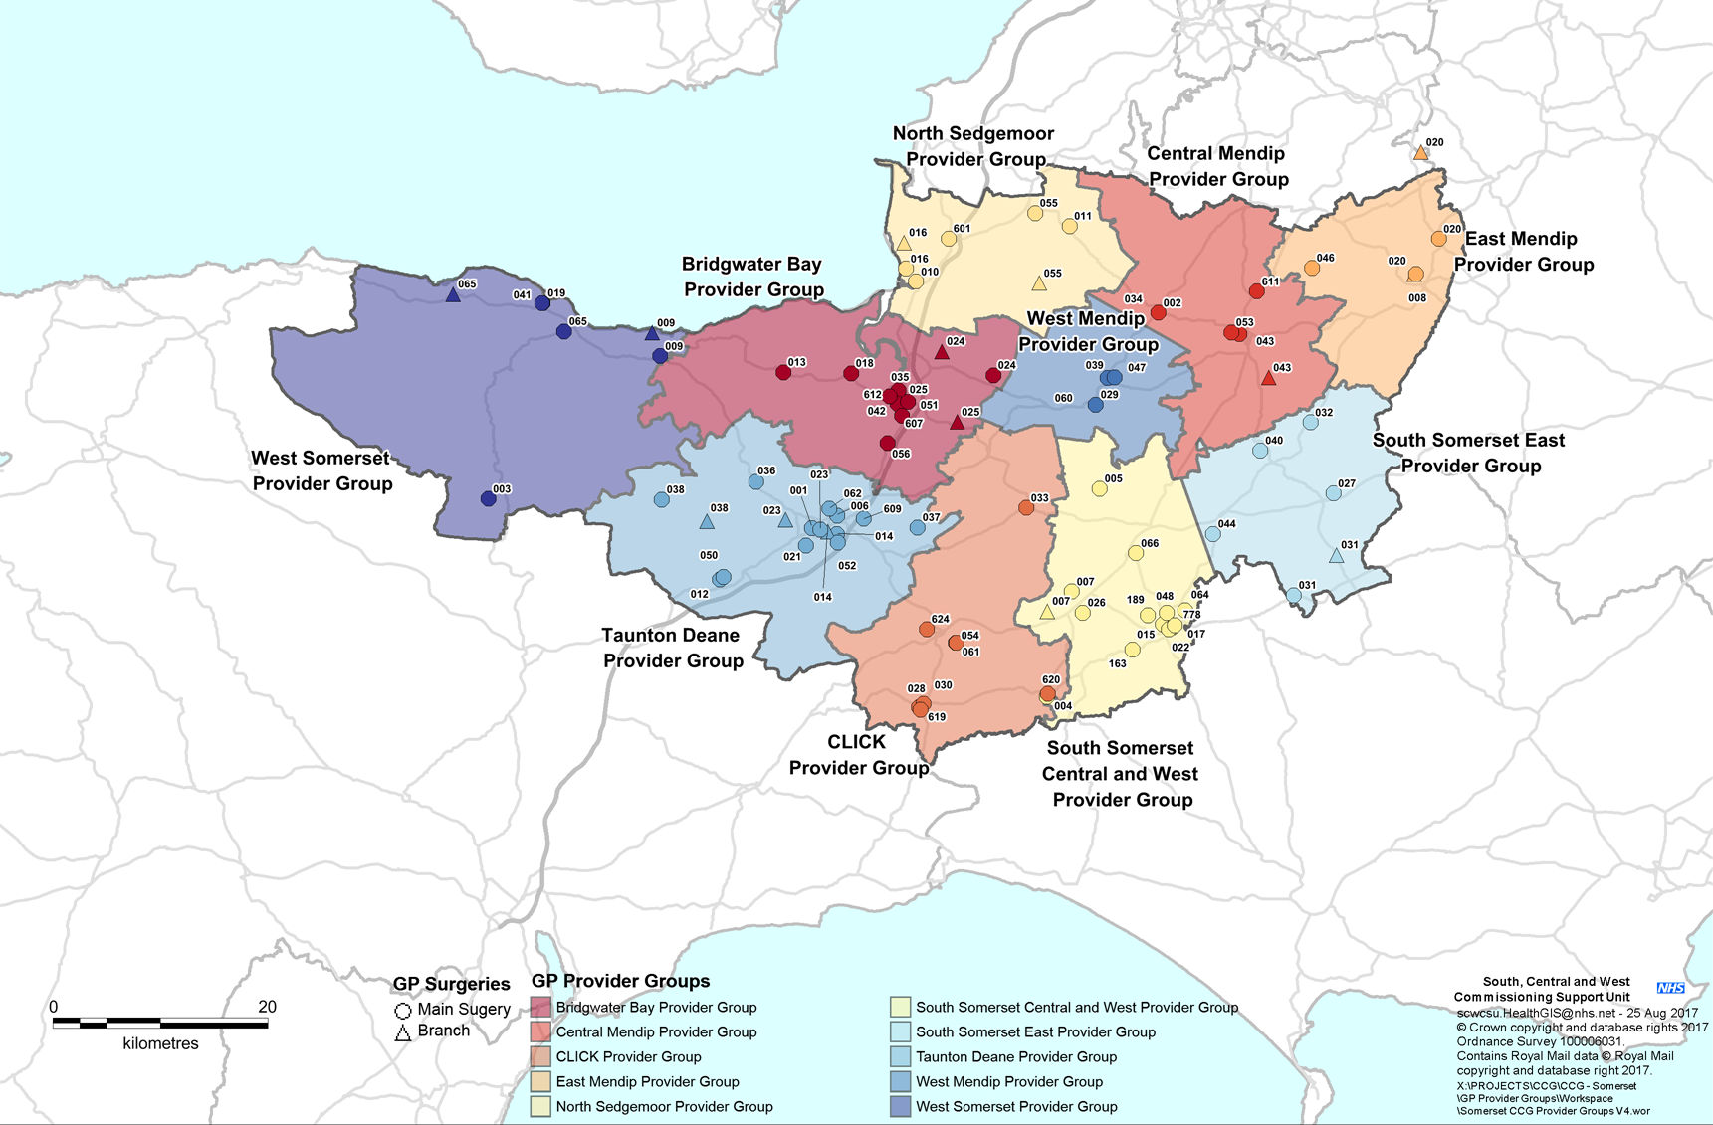
Improved Access Provider Groups
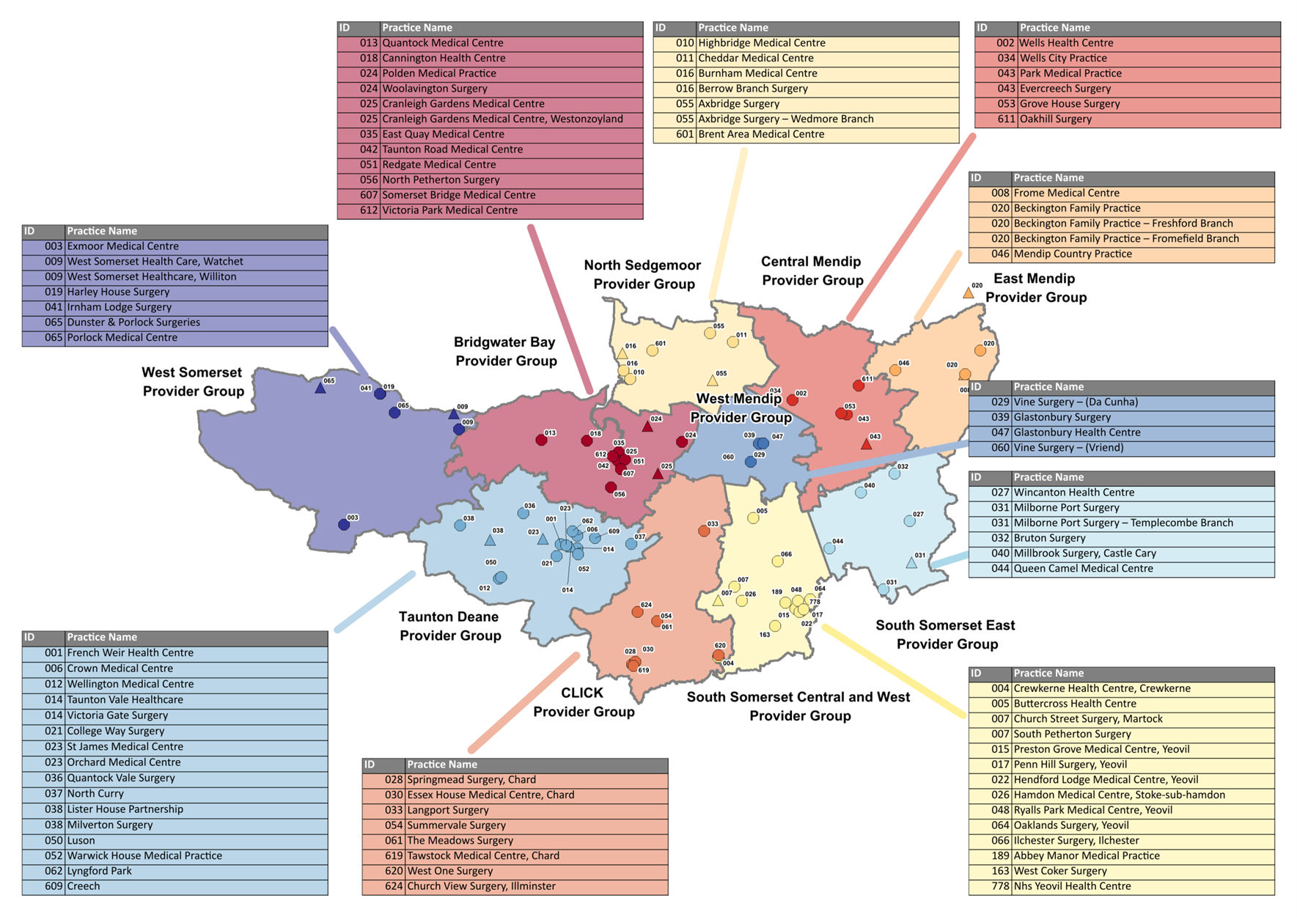
Improved Access Provider Groups and Practices
South Somerset East Provider Group
Taunton Deane Provider Group
Central Mendip Provider Group
West Mendip Provider Group
East Mendip Provider Group
South Somerset Central and West Provider Group
North Sedgemoor Provider Group
Bridgwater Bay Provider Group
West Somerset Provider Group

